TC-CMS-029
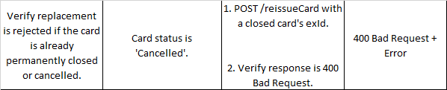
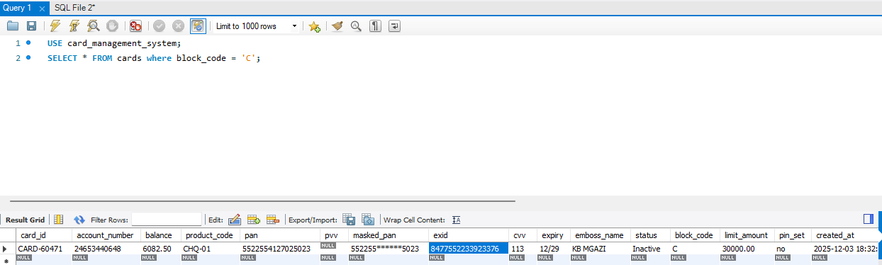
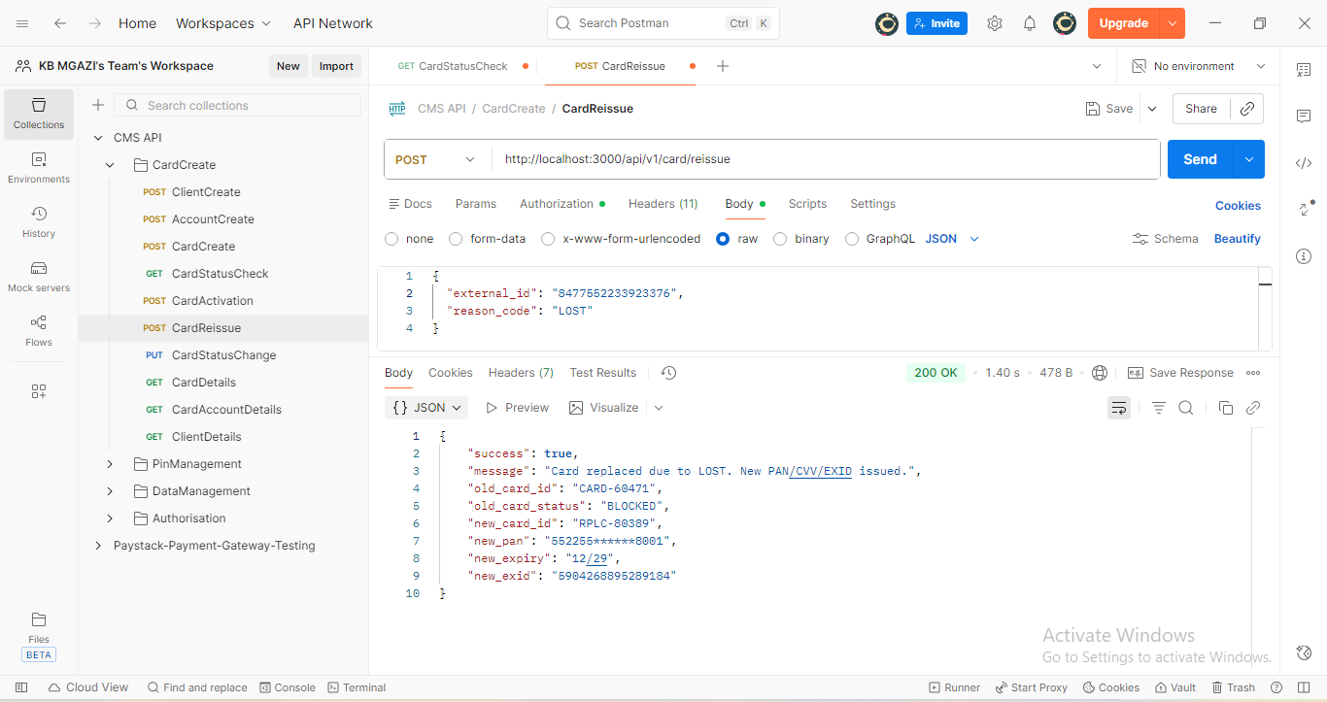
Request:
{
"external_id": "8477552233923376",
"reason_code": "LOST"
}
Response:
{
"success": true,
"message": "Card replaced due to LOST. New PAN/CVV/EXID issued.",
"old_card_id": "CARD-60471",
"old_card_status": "BLOCKED",
"new_card_id": "RPLC-80389",
"new_pan": "552255******8001",
"new_expiry": "12/29",
"new_exid": "5904268895289184"
}

